**Sampling Techniques**

1. **Simple random sample**
2. **Stratified Sample**
3. **Systematic sample**
4. **Cluster Sampling**
5. **Convenience Sampling**

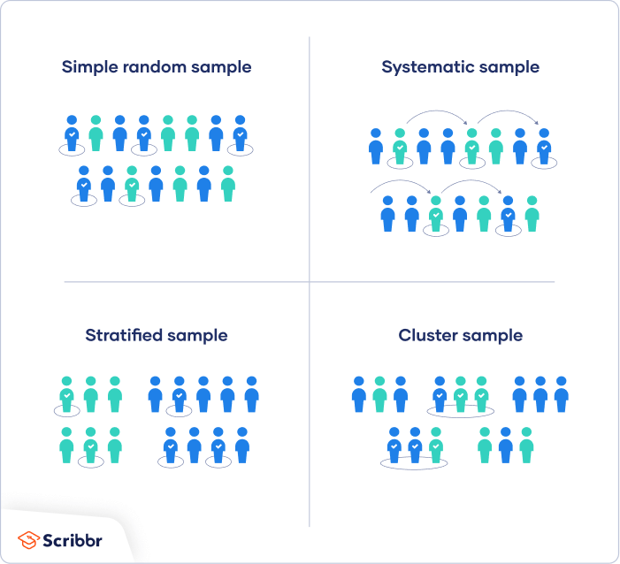

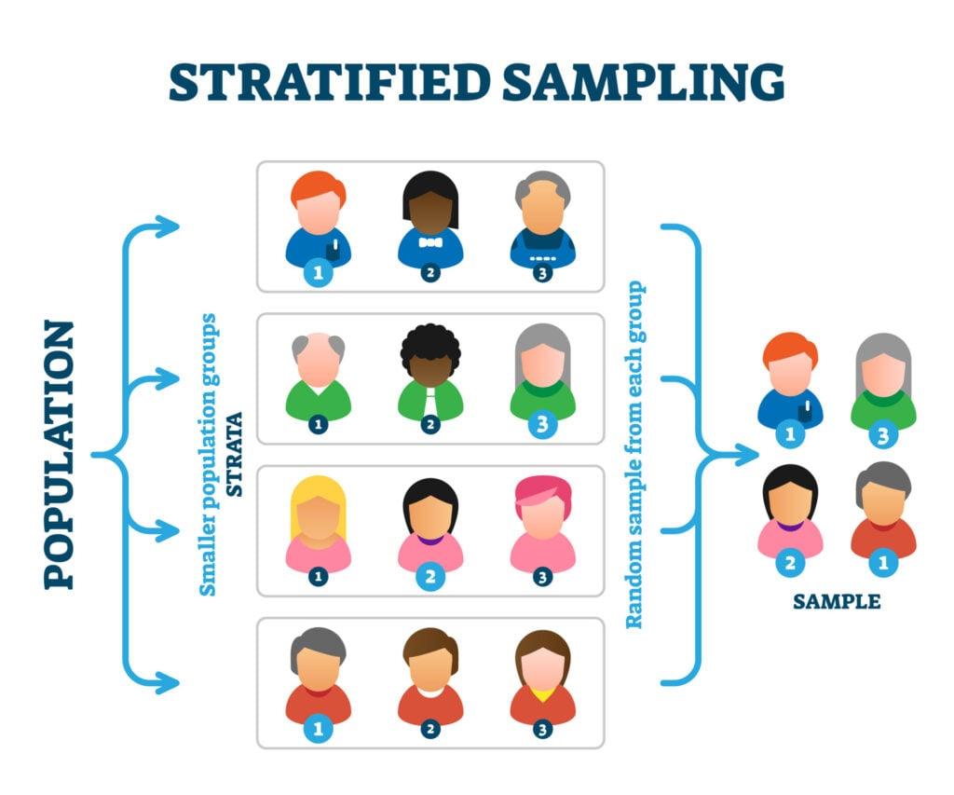

**Systematic sample**

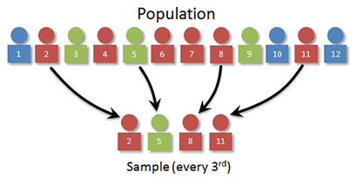

**Cluster Sampling**

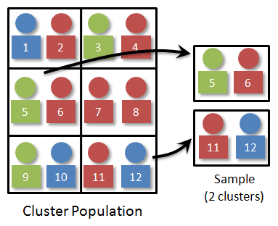

**Convenience Sampling**

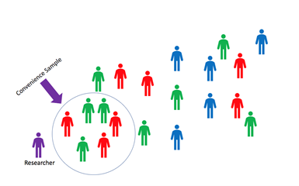

**Exercise:**

If I want to randomly pick 5 students to represent the class, how should I do it.

**You try:**

Design five different ways to sample 100 people in Rhode Island.